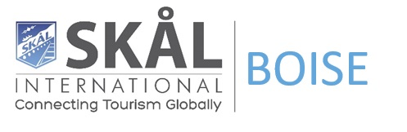

Lori Knipe
Skål International Boise
Skal International Resume-
It has been my honor and privilege to serve Skål Boise as the 2024 SIUSA Representative.As As I look forward to my growth within the Skål, I would be honored to continue serving by being on the board of Skal USA as Director.
Elected Positions:
- Skal Intl. Boise Past President /SIUSA Rep 2023-Present
- Skål Intl. Boise President 2020-2022
- Skål Intl. Boise Vice President 2018-2020
- Skål Intl. Boise Secretary 2016-2018

Skål International World Congress, USA- NAASC Congress, NCM and Board Meetings:
- Mexico 2023
- Winnipeg, Canada 2024
- Boise, Idaho 2016

